**C.Sabeetha Assignment-4**

Question-1: Write code and connections in wokwi for ultrasonic sensor. Whenever distance is less than 100 cms send “alert” to IBM cloud and display in device recent events.

Solution:

#define ECHO_PIN 2

#define TRIG_PIN 3

#define organization =”6woaty”

#definedeviceType=” arduino”

#definedeviceId =”6121”

#defineauthMethod ="use-token-auth"

#define authToken =”dyiWdE(AUUPy7ZKUij”

void setup() {

// put your setup code here, to run once:

Serial.begin(9600);

pinMode(TRIG_PIN,OUTPUT);

pinMode(ECHO_PIN, INPUT);

}

float readDistanceCM() {

digitalWrite(TRIG_PIN, LOW);

delayMicroseconds(2);

digitalWrite(TRIG_PIN, HIGH);

delayMicroseconds(10);

digitalWrite(TRIG_PIN, LOW);

int duration = pulseIn(ECHO_PIN, HIGH);

return duration * 0.034 / 2;

}

void loop() {

// put your main code here, to run repeatedly:

float distance = readDistanceCM();

if(distance <= 100)

{

Serial.println("person detected ");

}

else{

Serial.print("Measured distance: ");

Serial.println(readDistanceCM());

}

delay(1000);

}

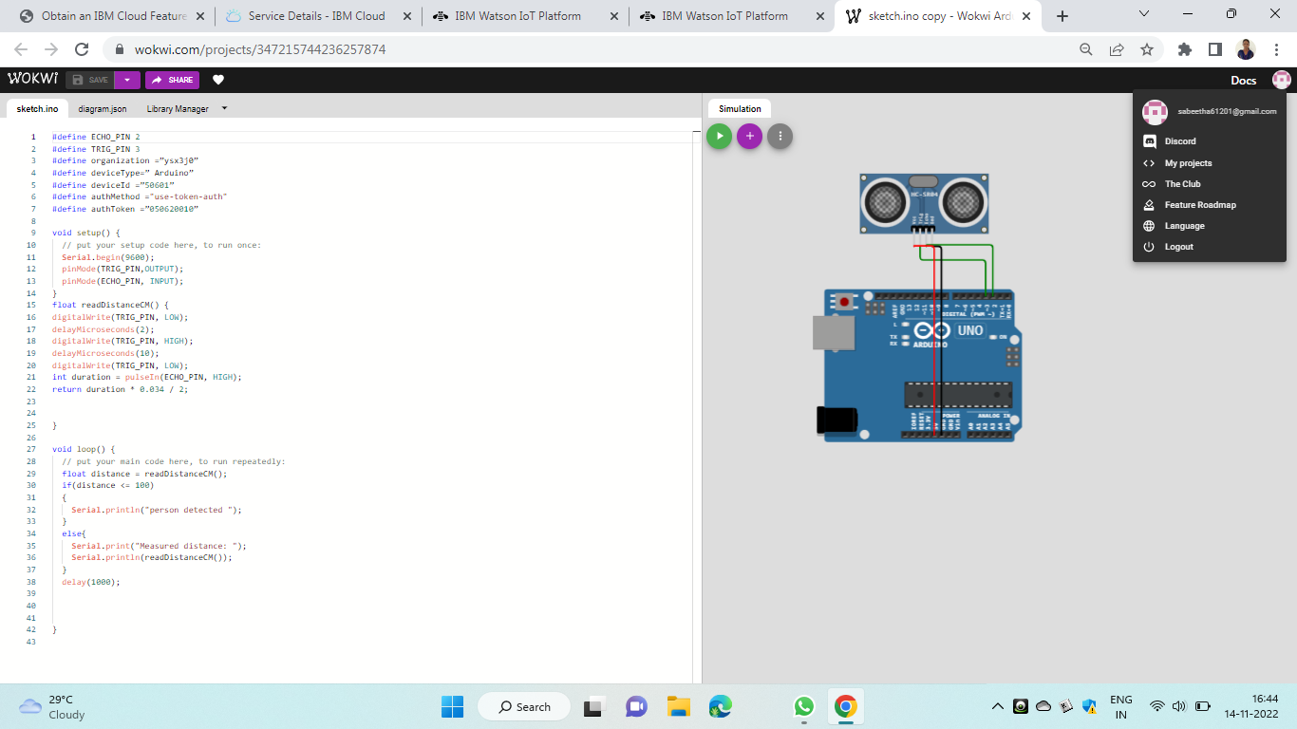

**Output:**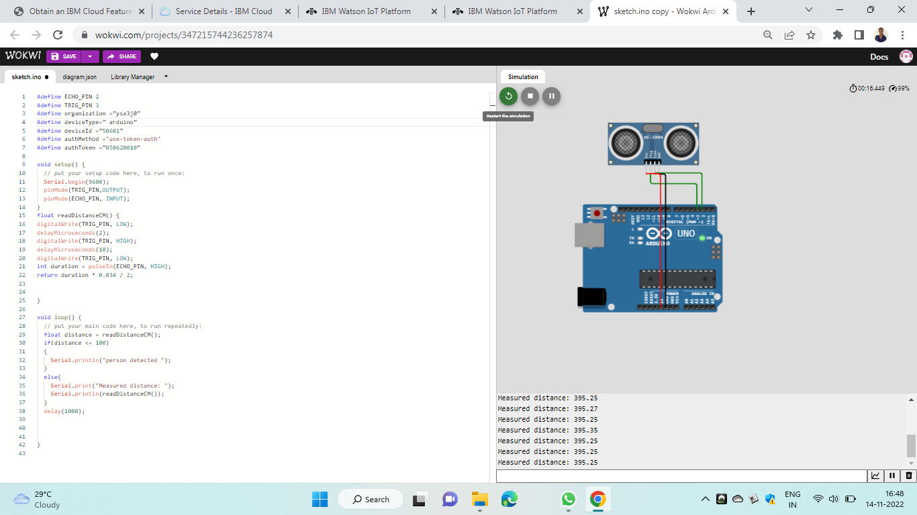

**Wokwi Link:** https://wokwi.com/projects/348301253973901908

**IBM CLOUD**

**Device Recent Events**

